

**Image File Format Converter**

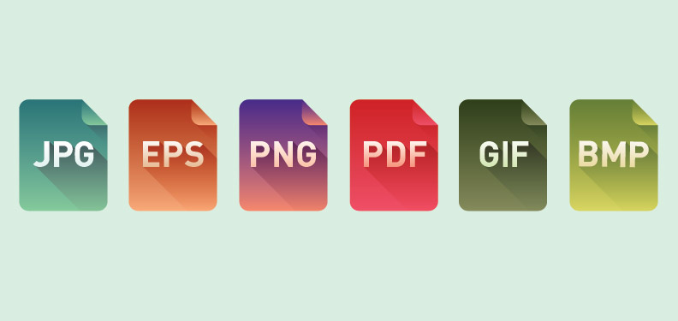

File formats:

An image file format may store data in uncompressed, compressed, or vector formats Once rasterized, an image becomes a grid of pixels, each of which has a number of bits to designate its color equal to the color depth of the device displaying it.

 two types of **image file compression** algorithms: lossless and lossy.

Raster vs Vector

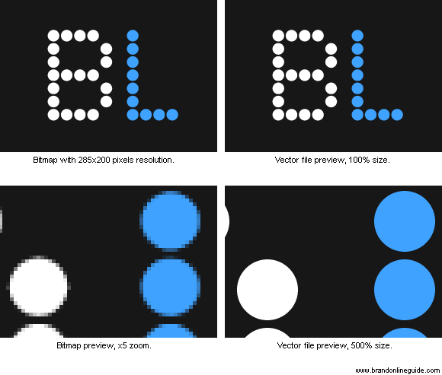

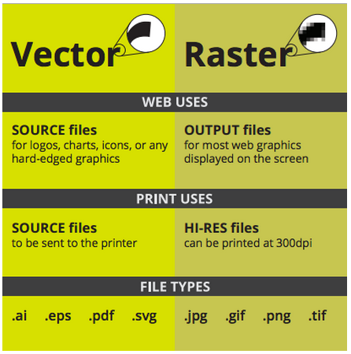

|  |  |  |  |  |  |  |  |  |  |  |  |  |  |
| --- | --- | --- | --- | --- | --- | --- | --- | --- | --- | --- | --- | --- | --- |
| **Format** | **Compression algorithm** | **Raster/ vector** | **Color depth** | **Indexed color** | **Transparency** | **Metadata** | **Interlacing** | **Multi-page** | **Animation** | **Layers** | **Color management** | **Extend­able** | **HDR format** |
| **AI** | Lossy and lossless | Both | 1, 8, 24, and 32 (possibly with multiple palettes) | Yes | Yes | Yes | No | No | No | Yes | Yes | Unknown | No |
| **BMP** | None, RLE, JPEG, and PNG | Raster | 1, 4, 8, 16, 24, and 32 | Yes | Yes | No | No | No | No | No | Yes | No | No |
| **CDR** | Lossy and lossless | Both | 1, 8, 24,and 32 (multiple palettes) | Yes | Yes | Yes | No | Yes | No | Yes | Yes | Unknown | No |
| **CPC** | CPC | Raster | 1 | No | No | Yes | No | Yes | No | No | No | Yes, via embedded dictionary | No |
| **EPS** | None, LZW,DEFLATE,RLE, DCT | Both | Device specific | No | Yes | Yes | N/A | Yes | No | Yes | Yes | Yes | Yes |
| **EXR** | None, RLE,ZIP, Piz, PXR24, and B44 | Raster | 16–128 (floating-point) | No | Yes | Yes | No | No | No | No | Yes | Yes | Yes |
| **GIF** | LZW | Raster | 1, 2, 3, 4, 5, 6, 7, and 8 | Yes | Yes; 1b plane-only mask using color index | Yes | Yes | Yes | Yes | Yes | No | Yes (GIF89a) | No |
| **HD Photo /JPEG XR** | Lossy and lossless bi-orthogonal transform | Raster | 1, 2, 8, 16, 24, 32, 48, 64, and 128 (floating-point) | No | Yes | Yes | Yes | Yes | No | No | Yes | Yes | Yes |
| **ILBM** | Optional run-length encoding | Raster | 1, 2, 4, 8, 16, 32, 64, 64 EHB, 128, 256 (8-bit), 4,096 (HAM6pseudo 12-bit), 4,096 pure 12-bit, 262, 144 (HAM8pseudo 18-bit), and24-bit | Yes | No | Yes | Yes | No | Yes, Palette-shifting | No | No | Yes | No |
| **IMA** | Lossy and lossless original mutiresolution analysis transformation | Raster | 8-bit, 16-bitinteger, 32-bit floating-point | No | Yes | Yes | No | No | No | No | Yes | Yes | Yes |
| **JPEG** | Lossy (and partly lossless),DCT, RLE, and Huffmanpredictive nearest neighbor | Raster | 8-bit(greyscale), 12-bit, and24-bit | No | No | Yes | Yes | No | No | No | Yes | No | No (see unofficialJPEG-HDR) |
| **JPEG 2000** | Lossy and lossless (DWT) | Raster | 8 and 16(greyscale) with possibly color up to48-bit | No | Yes | Yes | Yes | No | No | No | Yes | Unknown | No |
| **ORA** | Lossless | Both | 1, 2, 4, 8, 16, 24, 32, 48, and 64 | Yes | Yes | Yes | Yes | Yes | No | Yes | Yes | Yes | Yes |
| **PAM** | None | Raster | Up to 16 | No | Yes | Yes | No | Yes | No | No | No | Yes | No |
| **PCX** | None, RLE | Raster | 1, 2, 4, 8, 24 and 32 | Yes | Yes | No | No | Yes | No | No | No | No | No |
| **PGF** | Lossy and lossless (DWT) | Raster | greyscale: 1, 8, 16, 31; color: 12, 16, 24, 32, and 48 | Yes | Yes | Yes | Yes | No | No | No | No | Unknown | No |
| **PICT** | None, RLE, and QuickTime | Both | 1, 2, 4, 8, 16, 24, and 32 | Yes | Yes | Yes | Unknown | No | No | No | Unknown | No? | No |
| **PLD** | Optional ZIP, JPEG | Both | 1, 4, 8, 16, 24, 32, 48, and 64 | Unknown | Yes | Yes | Unknown | Yes | Yes | Yes | Yes | Yes | Yes |
| **PNG** | Lossless and DEFLATE | Raster | 1, 2, 4, 8, 16, 24, 32, 48, and 64 | Yes (1–8 bit modes) | Yes; 8b, 16b per-pixel alpha channel; 8b for indexed | Yes | Yes, Adam7 algorithm | No | No (but seeMNG andAPNG) | No | Yes | Yes, via chunks | No, see discussion |
| **PPM** | None | Raster | Up to 16 | No | No | Yes | No | Yes | No | No | No | No | No |
| **PSD** | None andRLE | Both | 1, 2, 4, 8, 16, 24, 32, 48, and 64 | Yes | Yes; 8b, 16b per-pixel alpha channel | Yes | N/A | No | Yes | Yes | Yes | No? | Yes |
| **PSP** | None | Both | 1, 2, 8, 16, 24, 32, and 48 | Yes | Yes; 8b and 16b per-pixelalpha channel | Yes | No | Unknown | No | Yes | Unknown | Unknown | No |
| **SVG** | None and lossless gzip | Vector[[8]](http://en.wikipedia.org/wiki/Comparison_of_graphics_file_formats#cite_note-8) | 24 and 32 | No | Yes | Yes | N/A | Yes (1.2 draft) | Yes (SMIL/SVG) | Yes | Yes | Yes, XMLbased | N/A |
| **TGA** | None, RLE, and other | Raster | 1, 2, 4, 8, 16, 24, and 32 | Yes | Yes | Yes | No | No | No | No | No | Unknown | No |
| **TIFF** | None, LZW,RLE, ZIP, and other | Both | 1, 2, 4, 8, 16, 24, and 32 | Yes (1–8 bit modes) | Yes | Yes | Yes, for JPEG compression | Yes | No | Yes | Yes | Yes, via tags | Yes, TIFF float |
| **WebP** | Lossy and lossless | Raster | 24 and 32 | No | Yes | Yes | No | Yes | Yes | No | Yes | Yes | No |
| **XAML** | None | Vector | 32 and 64 | No | Yes | Yes | N/A | Yes | Yes | Yes | No | Yes | Yes |
| **XCF** | None and lossless (gzipand bzip2) | Both | 8, 24, and 32 | Yes | Yes | Unknown | N/A | No | Yes | Yes | Yes | Yes | No |

**JPEG**

- RGB 24 bits (8 bit color)

-Grayscale 8 bits

-lossy compression

-used for photo images

-extension .jpg or .jpeg

**JPEG 2000**

**-**lossless and lossy compression (improve quality and compression ratio and require more computational power)

-used movie editing

#### Exif

-similar to the JFIF format

-used in most cameras and purpose is to record and to standardize the exchange of images with image metadata between digital cameras and editing and viewing software.

#### TIFF

-flexible format that normally saves 8 bits or 16 bits per color (red, green, blue) for 24-bit and 48-bit totals, respectively,

- **TIFF** or**TIF** filename extension.

-lossy and lossless;

-Some digital cameras can save images in TIFF format, using the LZWcompression algorithm for lossless storage.

-not widely supported by web browsers

- widely accepted as a photograph file standard in the printing business. TIFF can handle device-specific color spaces, such as the CMYK defined by a particular set of printing press inks.

-OCR (Optical Character Recognition) software packages commonly generate some form of TIFF image (often monochromatic) for scanned text pages.

#### RIF

**-**available on some digital cameras, rather than to a specific format.

-use a lossless or nearly lossless compression,

-produce file sizes smaller than the TIFF formats

- standard raw image format, (ISO 12234-2,TIFF/EP),

#### GIF

**-**limited to an 8-bit palette, or 256 colors.

-suitable for storing graphics with relatively few colors such as simple diagrams, shapes, logos and cartoon style images.

- supports animation and is still widely used to provide image animation effects.

-Its LZW lossless compression is more effective when large areas have a single color, and less effective for photographic or dithered images.

#### BMP

-handles graphics files within the Microsoft Windows OS.

-Typically uncompressed, and therefore large and lossless;

- advantage is their simple structure and wide acceptance in Windows programs.

#### PNG

created as a free, open-source alternative to GIF.

-supports 8 bit paletted images (with optional transparency for all palette colors) and 24 bit truecolor (16 million colors) or 48 bit truecolor with and without alpha channel - while GIF supports only 256 colors and a single transparent color.

-Indexed-color, grayscale, and truecolor images are supported, plus an optional alpha channel.

-Used in online viewing applications like web browsers

- robust, providing both full file integrity checking and simple detection of common transmission errors.

-Animated formats derived from PNG are MNG and APNG. The latter is supported by Mozilla Firefox and Opera and is backwards compatible with PNG.

#### PPM, PGM, PBM, and PNM

Netpbm format is a family including the **portable pixmap** file format (PPM), the **portable graymap** file format (PGM) and the **portable bitmap** file format (PBM). These are either pure ASCII files or raw binary files with an ASCII header that provide very basic functionality and serve as a lowest common denominator for converting pixmap, graymap, or bitmap files between different platforms. Several applications refer to them collectively as PNM (Portable aNy Map).

#### WEBP

-new open image formats

-lossless and lossy compression.

-Google to reduce image file size to speed up web page loading: its principal purpose is to supersede JPEG as the primary format for photographs on the web.

-WebP is based on VP8's intra-frame coding and uses a container based on RIFF.

#### HDR raster formats

-Most typical raster formats cannot store HDR data (32 bit floating point values per pixel component),

-. RGBE is the format for HDR images originating from Radiance and also supported by Adobe Photoshop.

#### BPG

**BPG** (Better Portable Graphics) is a new image format. Its purpose is to replace the JPEG image format when quality or file size is an issue. Its main advantages are:

* High compression ratio. Files are much smaller than JPEG for similar quality.
* Supported by most Web browsers with a small Javascript decoder (gzipped size: 76 KB).
* Based on a subset of the HEVC open video compression standard.
* Supports the same chroma formats as JPEG(grayscale, YCbCr 4:2:0, 4:2:2, 4:4:4) to reduce the losses during the conversion. An alpha channel is supported. The RGB, YCgCo and CMYK color spaces are also supported.
* Native support of 8 to 14 bits per channel for a higher dynamic range.
* Lossless compression is supported.
* Various meta data (such as EXIF) can be included.

**Vector Graphics**

Vector graphics are a geometric description of the data which can be rendered smoothly at any desired size. These geometric descriptions are based on mathematical expressions to represent image is computer graphics. Most vector image formats can also include colors, gradients, and image effects. Since vector graphics can be enlarged without losing quality, it makes them a good choice for logos and other types of drawings. At some point, all vector graphics must be rasterized in order to be displayed on digital monitors.

Following are the different vector file formats:

**.SVG (Scalable Vector Graphics):**

The World Wide Web Consortium (W3C) standard for vector graphics is Scalable Vector Graphics (SVG). In recent years SVG has become completely independent of the resolution of the rendering device, a printer or a display monitor. It is an XML-based vector image format for two-dimensional graphics with support for interactivity and animation.

**CGM (Computer Graphics Metafile):**

CGM (Computer Graphics Metafile) is a file format for 2D vector graphics, raster graphics, and text, and is defined by ISO/IEC 8632. All graphical elements can be specified in a textual source file that can be compiled into a binary file or one of two text representations. CGM provides a means of graphics data interchange for computer representation of 2D graphical information independent from any particular application, system, platform, or device.

#### Gerber:

#### Gerber format was developed by Gerber Systems Corp., now [Ucamco](http://en.wikipedia.org/wiki/Ucamco" \o "Ucamco), and is a 2D bi-level image description format. It is the de facto standard format used by [printed circuit board](http://en.wikipedia.org/wiki/Printed_circuit_board) or PCB software. It is also widely used in other industries requiring high-precision 2D bi-level images.

#### AI (Adobe Illustrator Artwork):

#### It is a proprietary file format developed by Adobe Systems for representing single-page vector-based drawings in either the EPS or PDF formats. The AI file format was originally a native format called PGF. PDF compatibility is achieved by embedding a complete copy of the PGF data within the saved PDF format file.

##### **CDR (Corel Draw Vector drawing file):**

CDR is a file extension for a vector graphics file used by Corel Draw, a popular graphics design program. Corel Paint Shop Pro and Adobe illustrator 9 and later can also open some CDR files. There is no publicly available CDR file format specification. Starting with Corel Draw 3, the file format changed to a Resource Interchange File Format (RIFF) envelope, recognizable by the first four bytes of the file being "RIFF", and a "CDR*version" in bytes 9 to 15.

**DrawingML:**

There are formats for word processing documents, spreadsheets and presentations as well as specific formats for material such as mathematical formulae, graphics, bibliographies etc. DrawingML is unrelated to the other vector graphics formats such as SVG. These can be converted to DrawingML to include natively in an Office Open XML document. This is a different approach to that of the OpenDocument format, which uses a subset of SVG, and includes vector graphics as separate files.

[**PDF**](http://en.wikipedia.org/wiki/Pdf)

Adobe's PDF format (Portable Document Format) is very widely used as a general purpose platform-independent document format. And while it is not exclusively used as such, it is also a very good vector image format. Adobe gives away the [Acrobat PDF reader](http://www.adobe.com/products/acrobat/readstep2.html), but sells the tools required to create PDF files (third party tools that perform the same task are also for sale). Those tools work with any program that is able to print. Support for reading and editing PDF files is much more limited.

**DXF:**

Drawing exchange Format. A CAD format from Autodesk used by CAD tools from many different vendors. Some programs have difficulty reading DXF files with splines (curves), so the Desktop Edition supports line+spline as well as line only output modes.

**EPS:**

Adobe's EPS format (Encapsulated PostScript) is perhaps the most common vector image format. It is the standard interchange format in the print industry. It is widely supported as an export format, but due to the complexity of the full format specification, not all programs that claim to support EPS are able to import all variants of it. Adobe Illustrator and recent versions of CorelDRAW have very good support for reading and writing EPS. Ghostview can read it very well but does not have any editing capabilities. Inkscape can only export it.

**.VSDX (Visio Drawing):**

Drawing file format introduced with Visio 2013, a program used for making drawings and technical illustrations; stores shapes, lines, text, and other objects arranged together on a free-form canvas; used for saving flowcharts, process diagrams, organizational charts, and other types of drawings. The VSDX format uses Open Packaging Conventions, which is based on XML and uses a .ZIP container to package all the drawing contents.

Reference:

<http://en.wikipedia.org/wiki/Comparison_of_graphics_file_formats>

<http://en.wikipedia.org/wiki/Image_file_formats>